NAME:- SUJAL SUTHAR

BATCH 12

ENROLLMENT NO CSE 25

CLASS 1-A

ESFP PRACTICAL 7 QUESTION 1

To learn about control structure (if, if-else, nested if-else, else-if ladder, switch case, and break, goto keyword) and typedef.

Q.1.Problem Definition:

The policy followed by a company to process customer orders is given by the following rules:

1. If a customer order quantity less than or equal to that in stock and his credit is OK, supply his requirement.
2. If his credit is not OK do not supply. Send him intimation.
3. If his credit is OK but the item in stock is

less than his order quantity, supply what is in

stock. Intimate to him that the balance will be shipped.

1. Assume, you have 100 quantities of computer available in stock.

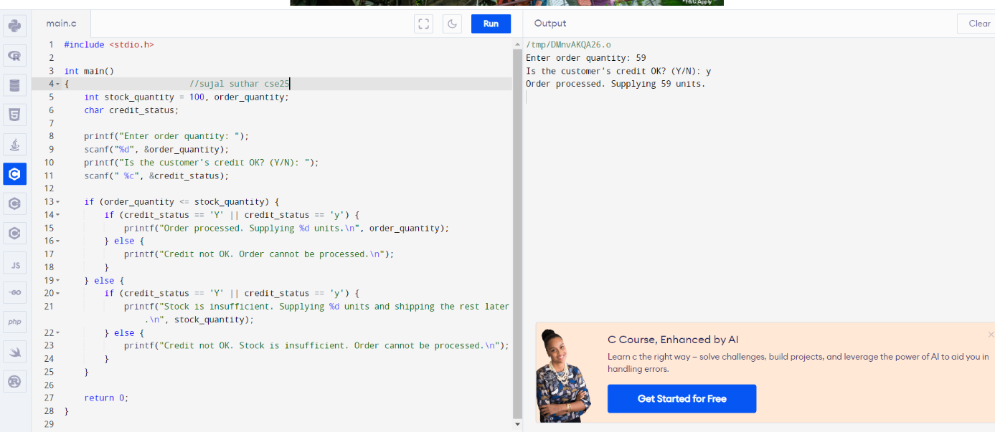

ESFP PRACTICAL 7 QUESTION 2

A certain grade of steel is graded according to the following conditions: 1. Hardness must be greater than 50

2. Carbon content must be less than 0.7 3. Tensile strength must be greater than

5600

The grade are as follows:

Grade is 10 if all three conditions are met. Grade is 9 if condition (i) and (ii) are met.

Grade is 8 if condition (ii) and (iii) are met.

Grade is 7 if condition (i) and (iii) are met. Grade is 6 if only one condition is met. Grade is 5 if none of the conditions are met.

Make a proper program, which will require the user to give value of hardness, carbon

content and tensile strength of the steel under consideration and as per the given input, output the grade of the steel. 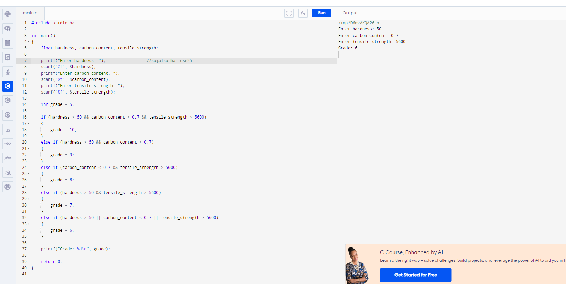

ESFP PRACTICAL 7 QUESTION 3

Q.3.Problem Definition:

Generate the following series with the help of goto keyword.

1. Generate series of natural number. 1, 2, 3, 4, 5, 6, 7, 8, 9, 10,

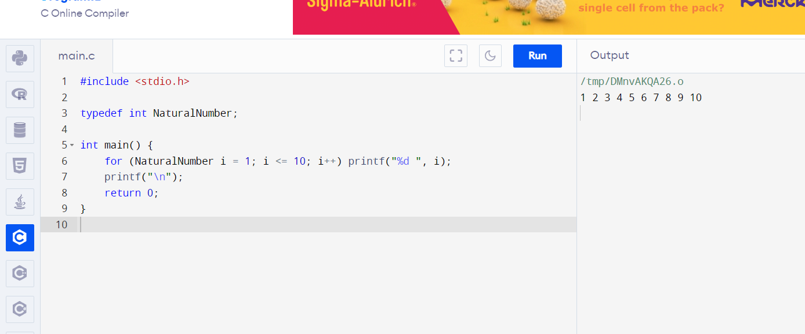

1. Generate table of any random number.

5, 10, 15, 20, 25, 30, 35, 40, 45, 50.

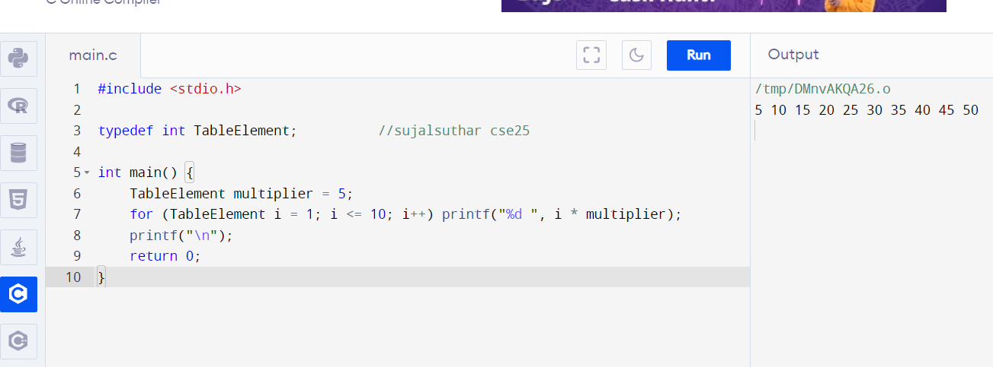

3. Generate series like:6,11,16,21,26,.....